SVKM’s NMIMS
Mukesh Patel School of Technology Management & Engineering
Computer Engineering Department
Program: B.Tech Integrated Sem V

Course: Basic Data Structures
2024-2025
Experiment No.01
PART A
(PART A : TO BE REFFERED BY STUDENTS)
A.1 Aim:
Introduction to Data Structures and implementation of Arrays

A.2 Prerequisite:
1. Knowledge of different types of data structures.
2. Fundamental concepts of C\C++.

A.3 Outcome:
After successful completion of this experiment students will be able to
- Identify the need of appropriate selection of data structure
- Explore the effect of appropriate data structure selection.
- Differentiate types of data structure based on their organization of data.
- Enlist the applications of different data structure.
- Implement arrays for the given problem

A.4 Theory:
A.4.1. Introduction of Data structure
- The data may be organized into many different ways. The logical and mathematical model of a particular organization of data is called data structure.
- A data structure helps you to understand relationship of one data element with the other and organize it within the memory.
- Data structure specified following:
  - Organization of data
  - Accessing methods
  - Degree of associativity
  - Processing alternatives for information
- Classification of data structure:
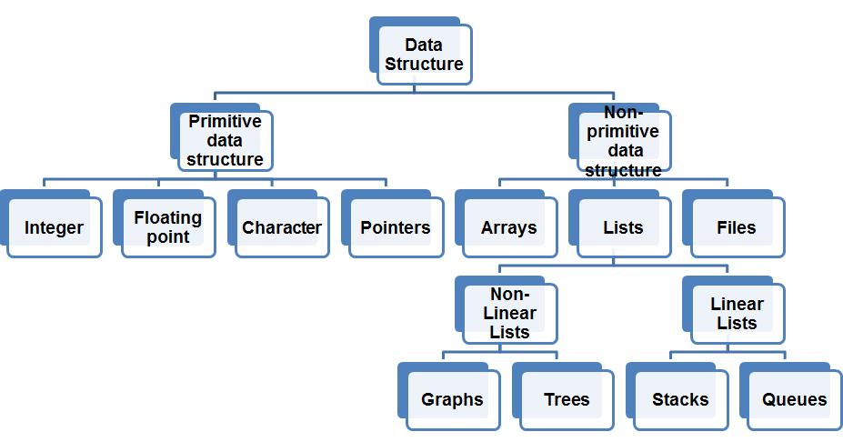

- Primitive data structure:
  - Basic structures
  - Directly operated upon by the machine instructions
- Non- Primitive data structures:
  - Derived from primitive data structure.
  - Emphasize on structuring of a group of homogenous or heterogeneous data structure.
  - Ex: Arrays, Lists, Files
- Various data structure:
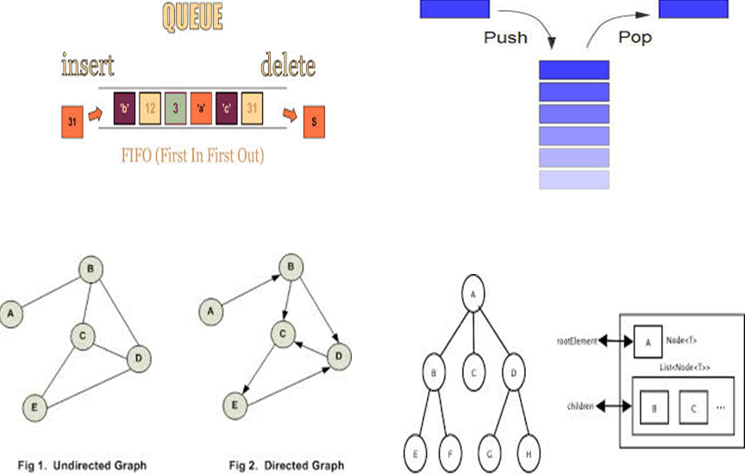

A.5 Procedure/Algorithm:
A.5.1:
TASK 1:
Write a C/C++ program of array to perform following (1D Array)
- Find the sum and Average of all the elements in an array.
- Find highest and lowest element in an array.
- Write a function that takes an array as input and returns a new array that is the reverse of the original array.

TASK 2:
Identify suitable data structure for given scenarios. Specify the reason for it.
- To implement a system for reversing a word.
- To implement a printer spooler so that jobs can be printed in the order of the arrival.
- To represent an image in a form of bitmap.
- For representing a city region telephone network.
- To store information about the directories and files in a system.
- To implement a system for parsing syntax.
- To implement back functionality in web browsers.
- To record the sequence of all the pages browsed in one session.
- To process network packets coming to the router.
- To represent machines on the internet and to find optimal paths between source machine and destination machine to send data.
- To represent connections\relations in social networking sites.
- Google maps to travel from your home to office in minimum time.

**********************
PART B
(PART B : TO BE COMPLETED BY STUDENTS)
(Students must submit the soft copy as per following segments within two hours of the practical. The soft copy must be uploaded on the Blackboard or emailed to the concerned lab in charge faculties at the end of the practical in case the there is no Black board access available)

Roll No. | Name:
Class : | Batch :
Date of Experiment: | Date of Submission
Grade : | Time of Submission:
Date of Grading:

B.1 Software Code written by student:
(Paste your code completed during the 2 hours of practical in the lab here)
Task 1:
Q1.
#include <stdio.h>

int main() {
int n;
printf("Enter size of an Array: ");
scanf("%d", &n);
int sum = 0;
int i;
int arr[n];

printf("Enter elements of an Array: ");
for(int i=0; i<n; i++) {
scanf("%d", &arr[i]);
}

for(int i=0; i<=n; i++) {
sum = sum + arr[i];
}
float avg = sum/n;
printf("Sum is : %d\n", sum);
printf("Average is: %f\n", avg);
return 0;
}

Q2.
// Find highest and lowest element in an array.

#include <stdio.h>

int main() {
int n;
printf("Enter size of an Array: ");
scanf("%d", &n);
int i;
int arr[n];

printf("Enter elements of an Array: ");
for(int i=0; i<n; i++) {
scanf("%d", &arr[i]);
}
int max = arr[0];
int min = arr[0];
for(int i=0; i<n; i++) {
if(arr[i] > max) {
max = arr[i];
}
if(arr[i] < min) {
min = arr[i];
}
}

printf("Maximum number is: %d\n", max);
printf("Minimum number is: %d\n", min);

return 0;
}

Q3.
// iii. Write a function that takes an array as input and returns a new array that is the reverse of the original array.

#include <stdio.h>

int main () {
int n;
printf ("Enter size of an Array: ");
scanf ("%d", &n);
int arr[n];
printf ("Enter elements of an Array: ");
for (int i = 0; i < n; i++)
{
scanf ("%d", &arr[i]);
}

printf("reversed Array: ");
for(int j=n-1; j>=0; j--) {
printf("%d\n ", arr[j]);
}

return 0;
}

Task 2:

B.2 Input and Output:
(Paste your program input and output in following format, If there is error then paste the specific error in the output part. In case of error with due permission of the faculty extension can be given to submit the error free code with output in due course of time. Students will be graded accordingly.)
Task 1:
Q1.
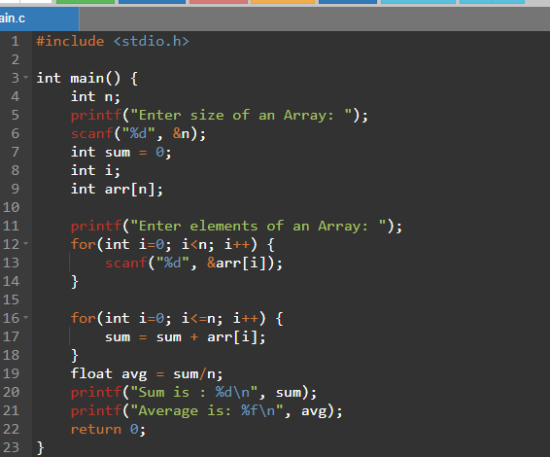

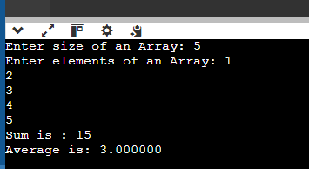
Q2.
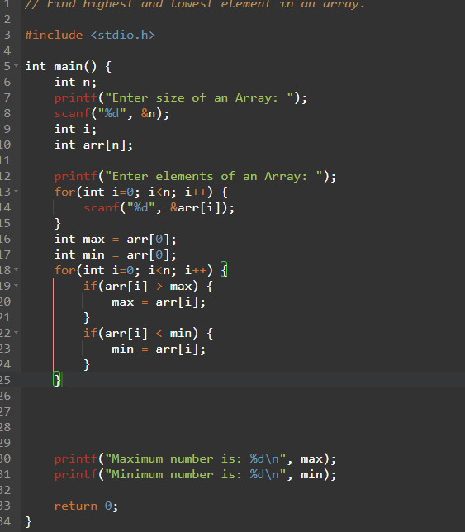

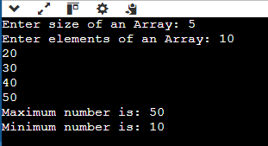

Q3.
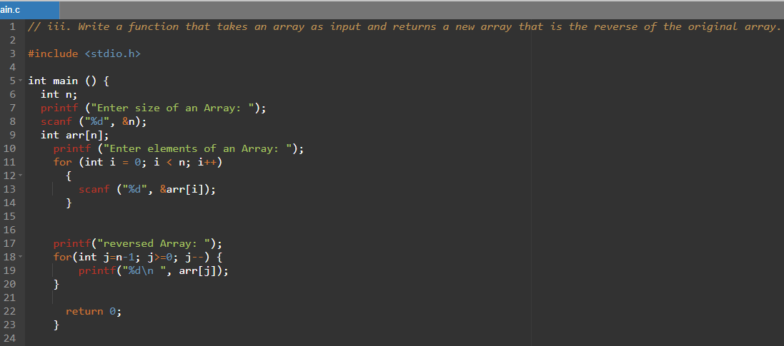

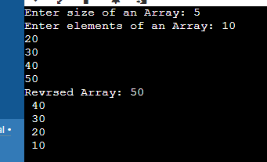

Task 2:
- Stack – because Stack follows LIFO principle i.e. Last in First Out.
- Queue - because queue follows FIFO principle i.e. First in First Out.
- Array – because array Use a 2D array where each element represents a pixel in the image. This structure allows efficient representation and manipulation of image data.
- Graph: Use a graph data structure where each telephone exchange (node) is connected to others (edges) based on the telephone lines between them. This allows representation of complex connections and paths..
- Tree: Use a tree data structure where each directory is a node, and files are the leaves. This hierarchical structure mirrors the file system's organization. To implement a system for parsing syntax.
- Stack: Use a stack to keep track of nested structures like parentheses, brackets, or tags in markup languages. This helps in ensuring that syntax is correct and balanced. To process network packets coming to the router.
- Stack: Use a stack to keep track of visited pages. When a user clicks "back", you pop the top item from the stack to return to the previous page.
- Linked List: Use a linked list where each node contains information about a visited page and a pointer to the next page in the sequence. This allows efficient insertion and deletion of page.
- Queue: Use a queue to manage incoming packets. This ensures that packets are processed in the order they are received (FIFO), which is crucial for network stability and fairness.
- Graph (Weighted): Use a weighted graph where machines are nodes and connections between them are edges with weights representing distances or costs. Algorithms like Dijkstra's or A* can then find optimal paths between nodes.
- Graph: Use a graph where each person is a node, and connections (friendships, follows) are edges between nodes. This structure allows efficient representation and querying of social connections.
- Graph (Weighted): Again, use a weighted graph where locations are nodes and roads or paths between them are edges with weights representing travel times or distances. Algorithms like Dijkstra's or A* can find the shortest path between your home and office.

B.3 Conclusion:
(Students must write the conclusion as per the attainment of individual outcome listed above and learning/observation noted in section B.3)
B.4 Question of Curiosity
(To be answered by student based on the practical performed and learning/observations)

Q1. Why appropriate selection of data structure is important in computer programming?

ANSWER:
To optimize efficiency of memory management, and to achieve the desired functionality accurately in a clear and maintainable way.

************************

